MOTOR BOARD DESIGN

AUTHOR: - Mohammed Tariq
DESIGN CREATED 1\FEB\2025
DESIGN LAST MODIFIED 5\FEB\2025
TOTAL PARTS IN DESIGN 11

Schematic capture
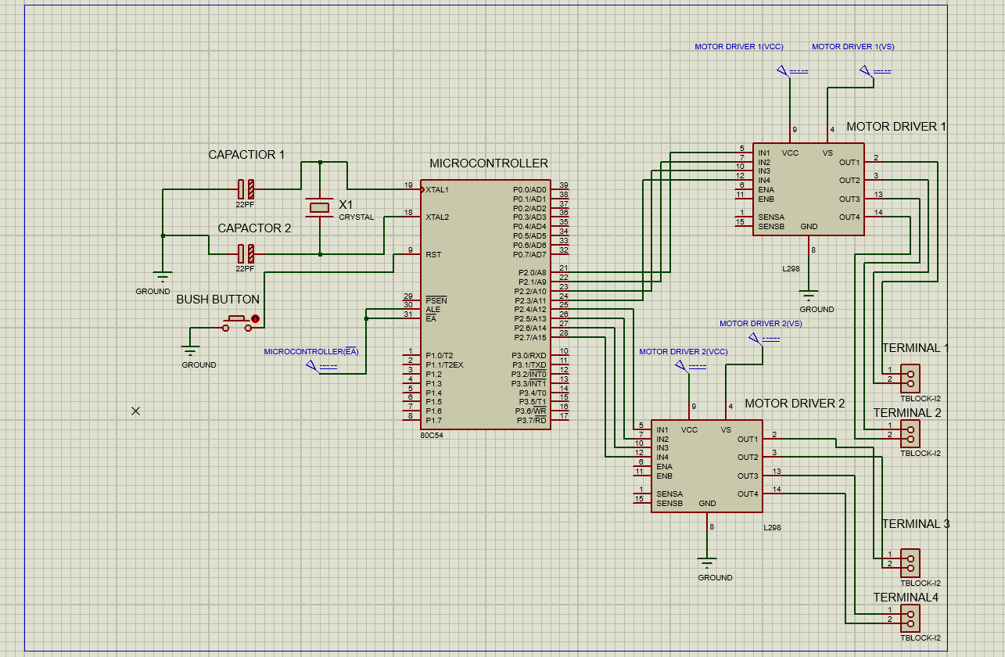

PCB layout

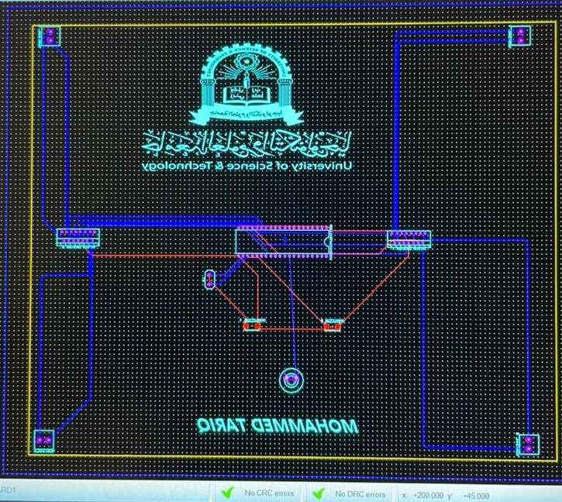

3D visualizer

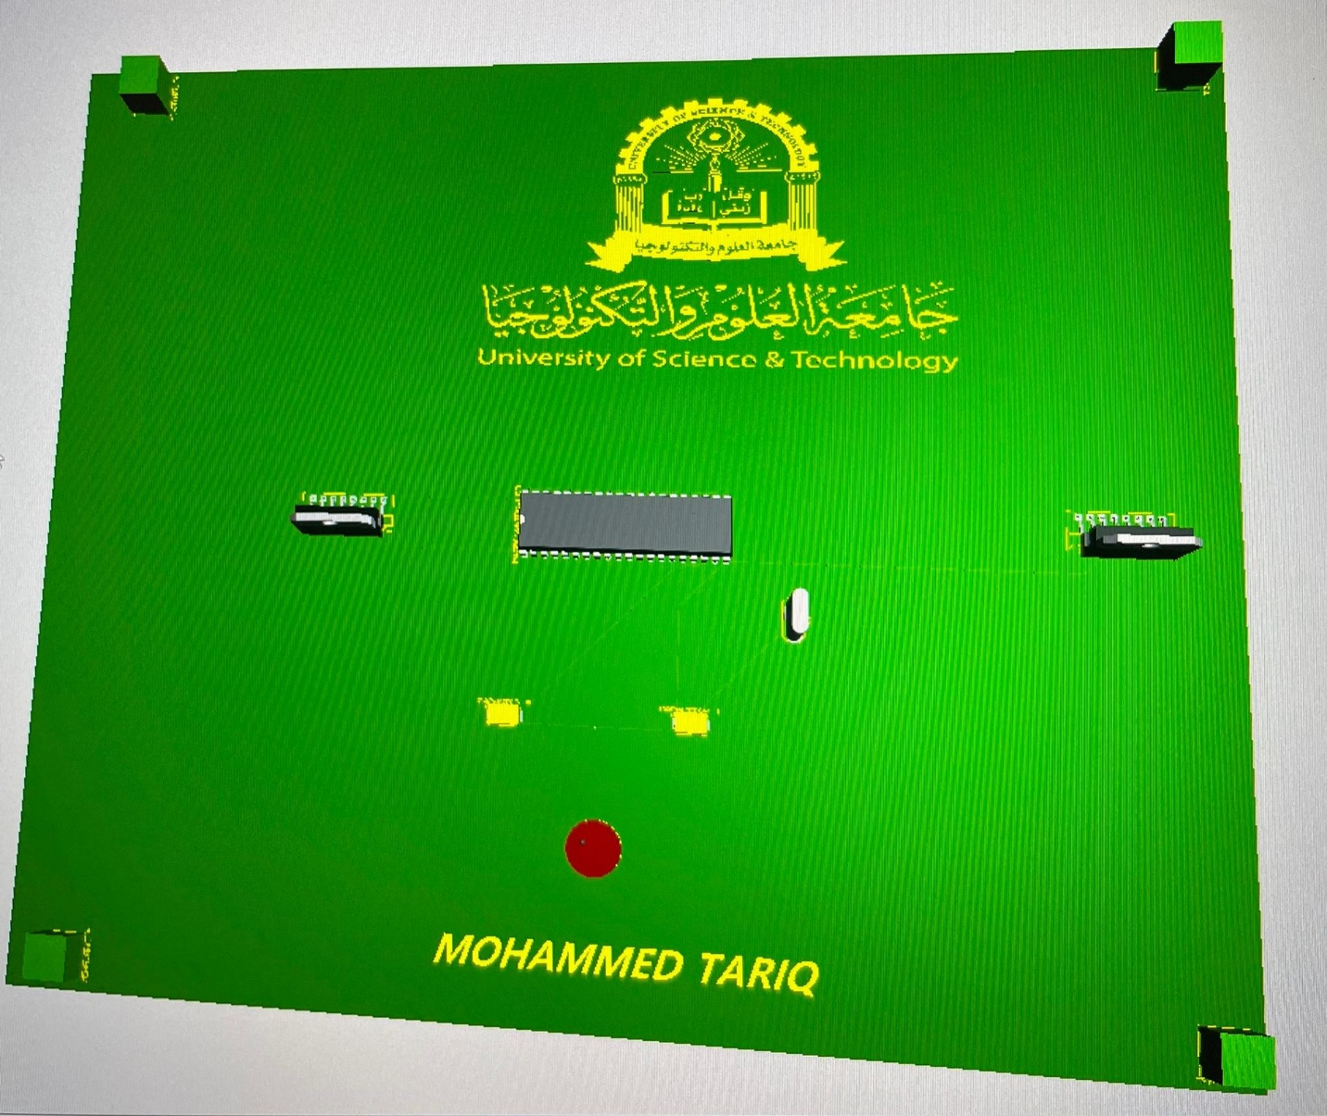

THE CODE FOR PROGRAMMING MICROCONTROLLER

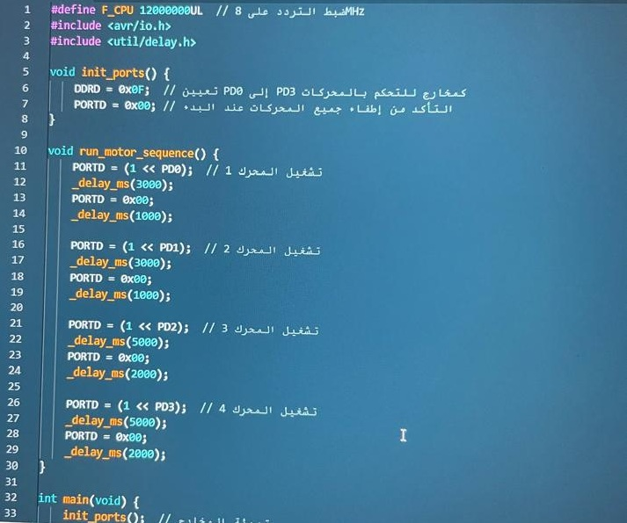

BILL OF MATERIALS

SERIAL  NUMBER | PART | QUANTITY | DESCRAPTION | price
80c54 | MICROCONTROLLER 8051 | 1 | Controlling all tasks in circuit | 3.9$
c | CAPACTOR | 2 | Regulate the frequency | 0.26$
button | BUSH BUTTON | 1 | reset | 10.19$
X1 | CRYSTAL | 1 | For clock frequency | 0.19$
L298 | MOTOR DRIVER | 2 | Controlling motors | 2.14$
TPLOCK-12 | TERMINAL | 4 | Screw terminal for motor | 0.41$

